|  |  |  |  |
| --- | --- | --- | --- |
| **Date:** | **15th July 2020** | **Name:** | **Sushmitha R Naik** |
| **Course:** | **Coursera** | **USN:** | **4AL17EC090** |
| **Topic:** | **Mathematics for Machine Learning: Linear Algebra** | **Semester & Section:** | **6th B sec** |
| **GitHub**  **Repository:** | **Sushmitha_naik** |  |  |

**DAILY ASSESSMENT FORMAT**

|  |
| --- |
| **FORENOON SESSION DETAILS** |
|  |



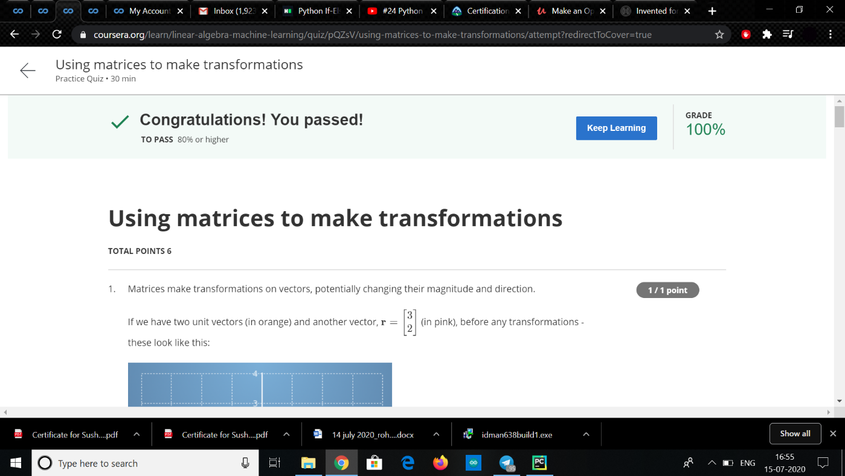

* **Matrix is an arrangement of numbers into rows and columns. Make your first introduction with matrices and learn about their dimensions and elements. A matrix is**
* **a rectangular arrangement of numbers into rows and columns. For example, matrix A has two rows and three columns.**
* **The mathematical concept of a matrix refers to a set of numbers, variables or functions ordered in rows and columns. Such a set then can be defined as a distinct entity, the matrix, and it can be manipulated as a whole according to some basic mathematical rules.**
* **Matrices can be used to compactly write and work with multiple linear equations, referred to as a system of linear equations, simultaneously. Matrices and matrix multiplication reveal their essential features when related to linear transformations, also known as linear maps.**
* **A matrix is a collection of numbers arranged into a fixed number of rows and columns. Usually the numbers are real numbers. In general, matrices can contain complex numbers but we won't see those here.**
* **In geology, matrices are used for making seismic surveys. They are used for plotting graphs, statistics and also to do scientific studies and research in almost different fields. Matrices are also used in representing the real world data's like the population of people, infant mortality rate, etc.**

**Main point of the Matrix:**

**The Matrix trilogy suggests that everyone has the individual responsibility to make the choice between the real world and an artificial world. Though Neo is the exemplar of free will, fate plays a large role in his adventure. Neo relies on the Oracle, and everything she says comes true in some way.**

**Application of Matrices:**

**Almost every branch of physics, including classical mechanics, optics, electromagnetism, quantum mechanics, and quantum electrodynamics, matrices are used to study physical phenomena, such as the motion of rigid bodies.**

**Matrices have also come to have important applications in computer graphics, where they have been used to represent rotations and other transformations of images. is a 2 × 3 matrix. A matrix with n rows and n columns is called a square matrix of order n**

**Matrices are classified according to the number of rows and columns, and the specific elements therein. (i) Row Matrix: A matrix which has exactly one row is called a row matrix. The above two matrices are row matrices because each has only one row.**

**Matrices are a useful way to represent, manipulate and study linear maps between finite dimensional vector spaces (if you have chosen basics).**

**The series primarily consists of a trilogy of science fiction action films beginning with The Matrix (1999) and continuing with two sequels, The Matrix Reloaded and The Matrix Revolutions (both in 2003), all written and directed by the Wachowskis and produced by Joel Silver.**

**The term matrix was introduced by the 19th-century English mathematician James Sylvester, but it was his friend the mathematician Arthur Cayley who developed the algebraic aspect of matrices in two papers in the 1850s.**

**In biology, matrix is the material (or tissue) in animal or plant. Structure of connective tissues is an extracellular matrix It is found in various connective tissue. It is generally**

**used as a jelly like structure instead of cytoplasm in connective tissue.**

**BONE CELLS. Bone matrix is synthesized by a layer of osteoblasts on the bone surface (Figs. 1-22 and 1-23). The osteoblasts are mesenchymal in origin and characterized by their abundant endoplasmic reticulum and their production of the enzyme alkaline phosphatase.**

**In the mitochondrion, the matrix is the space within the inner membrane. The word "matrix" stems from the fact that this space is viscous, compared to the relatively aqueous cytoplasm.**

**The extracellular matrix (ECM) is the non-cellular component present within all tissues and organs, and provides not only essential physical scaffolding for the cellular constituents but also initiates crucial biochemical and biomechanical cues that are required for tissue morphogenesis, differentiation and homeostasis.**